Read sections 2.1 - 2.8 of your textbook. The following review questions should help guide your reading. Points possible 30

**For each question, you should give a correct answer (as best you know it) or provide an intelligent question regarding the reading that applies to this question and explains why you could not answer the question. (Please note that "I didn't understand any of this" isn't a question, isn't intelligent, and has spelling and grammar errors. It will receive 0 points.)**

**Make sure to show your work. Answer the questions using your own words and understandings on the chapter materials.**

1. **R2.** What is the difference between network architecture and application architecture?
   1. Network architecture is the design of a computer or set of computers network and is the framerwork for the all the components and protocols that make up that network. An application architecture describes the behavior of any application and how the application is supposed to function and behave with different protocols for different cases.
2. **R5.** What information is used by a process running on one host to identify a process running on another host?
   1. The IP address of the destination host and the port number of the destination socket.
3. **R6.** Suppose you wanted to do a transaction from a remote client to a server as fast as possible. Would you use UDP or TCP? Why?
   1. UDP is faster than TCP because it has a continuous packet stream. This can cause packet loss though.
4. **R11.** Why do HTTP, SMTP, and POP3 run on top of TCP rather than on UDP?
   1. It is important that all information is received correctly in the full amount. TCP makes sure there is no packet loss. It would not be okay if you were missing half a webpage or email.
5. **R13.** Describe how Web caching can reduce the delay in receiving a requested object. Will Web caching reduce the delay for all objects requested by a user or for only some of the objects? Why?
   1. Web caching makes the desired content or data more avaliable to the used. Caching reduces on traffic on the links
6. **R20.** Look over your received e-mails, and examine the header of a message sent from a user with a .edu e-mail address. Is it possible to determine from the header the IP address of the host from which the message was sent? Do the same for a message sent from a Gmail account.
   1. You can hypothetically discover the IP address of the sender. But there is NAT technology that gives a new IP address according to the server it is sent across so it is like having a mask.
7. **P4.** Consider the following string of ASCII characters that were captured by Wireshark when the browser sent an HTTP GET message (i.e., this is the actual content of an HTTP GET message). The characters <cr><lf> are carriage return and line-feed characters (that is, the italized character string <cr> in the text below represents the single carriage-return character that was contained at that point in the HTTP header). Answer the following questions, indicating where in the HTTP GET message below you find the answer.

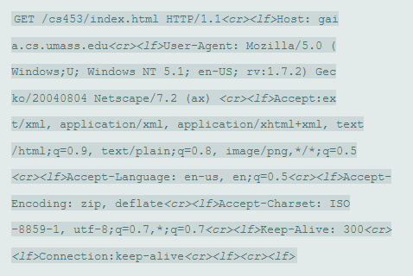

1. What is the URL of the document requested by the browser?
   * Gaia.cs.umass.edu
2. What version of HTTP is the browser running?
   * V1.1
3. Does the browser request a non-persistent or a persistent connection?
   * Persistent
4. What is the IP address of the host on which the browser is running?
5. What type of browser initiates this message? Why is the browser type needed in an HTTP request message?
   * Firefox. A connection establishment is required.
6. **P5.** The text below shows the reply sent from the server in response to the HTTP GET message in the question above. Answer the following questions, indicating where in the message below you find the answer.

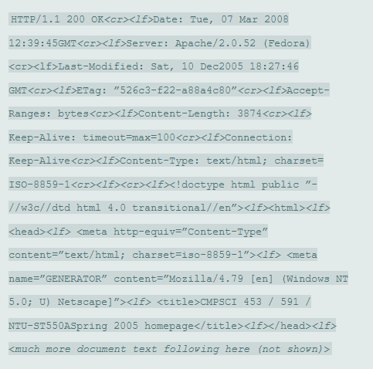

Was the server able to successfully find the document or not? What time was the document reply provided?

1. When was the document last modified?
   * Sat, 10 DEC2005
2. How many bytes are there in the document being returned?
   * 3874
3. What are the first 5 bytes of the document being returned? Did the server agree to a persistent connection?
   * <!doc are the first 5 bytes being returned. The server agreed to a persistent connection as told by the “Keep-Alive”
4. **P9.** Consider Figure 2.12 , for which there is an institutional network connected to the Internet. Suppose that the average object size is 850,000 bits and that the average request rate from the institution’s browsers to the origin servers is 16 requests per second. Also suppose that the amount of time it takes from when the router on the Internet side of the access link forwards an HTTP request until it receives the response is three seconds on average (see Section 2.2.5). Model the total average response time as the sum of the average access delay (that is, the delay from Internet router to institution router) and the average Internet delay. For the average access delay, use **Δ/(1−Δβ),**

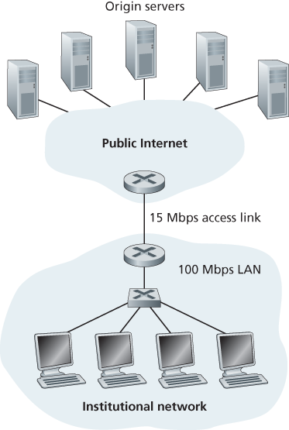

15,000,000 bits/sec

1. Find the total average response time. (Remember L/R)
   1. 850,000 bits/15000000 bits/sec = 0.57 seconds
2. Now suppose a cache is installed in the institutional LAN. Suppose the miss rate is 0.4. Find the total response time. For this first find the traffic intensity for given 16 requests and then average access delay and add them to find the total response time.
   1. ???????????? Help. I’m not sure where to start